AN ASSESMENT OF THE FACTORS LEADING TO EMPLOYEES TURNOVER IN PUBLIC ORGANIZATIONS
A CASE STUDY OFUBUNGOMUNICPAL COUNCIL

BY
NZIKU, ROSALIA J
BLRPM/T.2019/201

A Dissertation to be submitted on Department of Labour Studies in Partial Fulfillment of the Required Award for Bachelor Degree in Labour Relations and Public Management (BLRPM)
Institute of Social Work
2022

CERTIFICATION
I, the undersigned, certify that we have read and hereby recommend for acceptance by the Institute of Social Work, a thesis entitled “An Assessment of the Factors Leading to Employee Turnover in Tanzania, a Case of Ubungo Municipal Council”, in partial fulfillment of the requirements for award of the Bachelor’s degree in Labour Relations and Public Management (BLRPM) at the Institute of Social Work.

__________________________
Dr………………
(Supervisor)

____________________________
Date

DECLARATION
I, Nziku, Rosalia J declare that a dissertation entitled “ An Assessment of the Factors Leading to Employees Turnover in Tanzania”, A Case study of Ubungo Municipal Council is my original work and has not been submitted and will not be presented to any other College, Institution or University other than the Institute of the Social Work for academic award.

_______________________________
Signature

______________________
Date

COPYRIGHTS
This dissertation is a copyright material protected under the Copyright Act 1999 and other enactments. It may not be reproduced by any means in full or part, except for short extracts in fair dealings, for research or private study, critical scholar review or discourse with an acknowledgement, no part of this dissertation may be reproduced, stored in any retrieval system, or transmitted in any form by any means, electronic, mechanical, photocopying, recording or otherwise without prior written permission of the author or the Institute of Social Work (ISW) on that behalf.

ACKNOWLEDGEMENTS
I would like to thank GOD our almighty He is the one who guided me on the true path, provided to me a knowledge that facilitated me to finish my research which is very important part of my studies. I acknowledge the efforts made by my friends for their tireless encouragement and reading my work. Also my earnest support to my supervisor of Institute of Social Work Dr.Eventius Mugyabuso for his tireless help during the whole process of making this dissertation complete. His diligent guidance throughout the study enriched and created direction for this dissertation. I very much appreciate his contribution. I also thank the management of the Institute of Social Work (ISW) for giving me the opportunity for higher learning. Not only that but also ISW staffs for their diligent facilitations during my studies.

DEDICATION
This research report is dedicated to my precious family especially my lovely parents MR & MRS JOHN NZIKU who were the wonderful supporters until my research was completed, and to my beloved fellow students, who had been encouraging me all the time for this research to be completed.

ABBREVIATIONS

BLRPM Bachelor`s Degree in Labour Relations and Public Management
ERS Economic Reform Program
ILRI International Livestock Research Institute
ISW Institute of Social work
SAP Structural Adjustment Programs
UN United Nations

TABLE OF CONTENTS

CERTIFICATION i
DECLARATION ii
COPYRIGHTS iii
ACKNOWLEDGEMENTS iv
DEDICATION v
ABBREVIATIONS vi
TABLE OF CONTENTS vii
LIST OF TABLES x
LIST OF FIGURES xi
ABSTRACT xii

CHAPTER ONE 1
INTRODUCTION AND BACKGROUNG OF THE STUDY 1
1.1 Introduction 1
1.2 Background of the Study 1
1.3 Statement of the Problem 3
1.4 General Objective of the Study 3
1.5 Specific Objectives of the Study 4
1.6 Research Questions 4
1.7 Scope of the Study 4
1.8 Significance of the Study 4
1.9 Limitations of the Study 5
1.10 Organization of the study 5

CHAPTER TWO 6
LITERATURE REVIEW 6
2.1 Introduction 6
2.2 Definition of key terms 6
2.1.1 Employee 6
2.2.2 Employees turnover 6
2.2.3 Voluntary turnover 7
2.3 Theoretical Reviews 8
2.3.1 Herzberg’s two factor theory 8
2.3.2 Expectancy Theory 9
2.3.3 Equity Theory or Adams equity theory 10
2.4 Empirical Review 10
2.5 Research Gap 12
2.6 Conceptual Frame Work. 12
2.7 Chapter summary 14

CHAPTER THREE 15
RESEARCH METHODOLOGY 15
3.1 Introduction 15
3.1 Research Design 15
3.2 Sampling frame 15
3.3 Sample size Determination 15
3.4 Sampling Technique 16
3.5 Data Collection Methods 16
3.6 Primary Data 17
3.7 Data Processing, Analysis and Presentation 17

CHAPTER FOUR 18
DATA PRESENTATON AND ANALYSIS 18
4.1 Introduction 18
4.2 General Information of Respondents 18
4.2.1 Age of the respondents 18
4.2.2 Gender of the respondents 19
4.2.3 Working experience 20
4.3 Presentations of Findings analysis & Discussion 21
4.3.2 Main forms of employee turnover at Ubungo Municipal Council 23
4.3.3 StrategieswhichcanbeadoptedtoretainemployeesatUbungo Municipal Council 25

CHAPTER FIVE 27
SUMMARY, CONCLUSION AND RECOMMENDATIONS 27
5.1 Chapter overview 27
5.2 General Summary 27
5.3 Summary of findings 27
5.4 Recommendations 29
5.4.1 Recommendations to organization 29
5.4.2 Recommendations for further researches 30
References 31
Appendices 33
Appendix One: Questionnaires to Employees 33

LIST OF TABLES
Table 4.1:Age of the respondents 18
Table 4.2: Gender of the respondents 19
Table 4.3: Respondents’ working experience 20

LIST OF FIGURES

Figure 2.1: Conceptual framework of the studyshows the Relationship between Variables 13
Figure 4.1: Causes of employee turnover 22
Figure 4.3: Employee retention strategies 25

ABSTRACT
Three decades ago, the concept of ‘works for life in one organization was a practical situation across organizations of that era. There was a positive relationship between employers and employees a factor, which led to extensive tenure in same organization despite poor, unattractive motivation and no or irrelevant compensation programs. It was very rare to see employee’s voluntary leaving one organization in favor of the other. Nowadays, if an organization does not have proper motivation and attractive compensation programs, it is likely to experience high risk of employee turnover. Currently, in Tanzania, many Public organizations are experiencing high rate of employees’ turnover; the determinants cause of the problem tends to differ from one organization to another. The Ministry of water also experiences the problem of employees’ turnover since 2009 to date, the percentages of employees’ turnover rate is approximately to 17% per year. As a way of addressing the problem, MoW introduced various retention and motivational strategies that ensure employees’ commitment to the organization. Such as extra duty allowances, sitting allowances when attending seminars or workshop, special loan for the staff to purchase cars or buildings, training opportunities for the staff, departments meetings which are conducted weekly, staff meetings known as “Workers’ Council” conducted four times annually, management meeting held in every Friday to ensure staff fully involved in decision making as well as OPRAS which provide feedback to employees regarding their performance. Despite all these efforts, the Ministry still experiences high rate of employees’ turnover.
This study aimed to provide the Factors Leading to Employees Turnover in Public Organizations, a Case of Ubungo Municipal Council, with three specific objectives; - To find out the main causes of employee’s turnover at Ubungo Municipal Council, to establish the main forms of employee turnover at Ubungo Municipal Council, and to determine the strategies which can be adopted to retain employees at Ubungo Municipal Council
The researcher used qualitative research approach to collect data, the descriptive and case study research design was used as framework of this study and target population was about 97 which calculated to get the sample size of 86 respondents.
Findings showed that employees turnover is caused by both internal and external factors such as poor employee relations and the need for self-development, and the main types of employee turnover are voluntary and the involuntary turnover.
The researcher recommended that the organization should improve the employee relations, improves the incentive systems of the employees, provide opportunities for employee growth and development, so as to overcome employee turnover in the organization.

CHAPTER ONE

INTRODUCTION AND BACKGROUNG OF THE STUDY

1.1 Introduction
The research aim was to determine Factors Leading to Employee Turnover in Public Organization, a case of Ubungo Municipal Council.
This chapter consisted of six parts, namely; background, statement of the problem, general objective of the study, specific objectives of the study, significance of the study and the limitations of the study.

1.2 Background of the Study
The term “turnover” is defined by Lashley (2000) as, “the ratio of the number of employees who have left during the period being considered divided by the average number of people in that organization during that period”. High labour turnover will influence negatively on associate degree organization’s capability to satisfy clients’ wants and supply quality services, and have an effect on the morale of the workers and therefore the productivity of these UN agency remains. (Shields and Ward, 2014)
The cost of labour turnover to organization is extremely obvious, Armstrong, (2006) delineate the subsequent prices the organization is probably going to suffer because of workers turnover , going away prices – payroll prices and personnel administration of migrator, direct price of recruiting replacements (advertising, interviewing, testing etc), cost of your time spent by time unit and line managers in accomplishment, direct price of introducing replacements (induction course, price of induction manuals etc); {opportunity price cost} of your time spent by time unit and managers in introducing new starters; direct cost of coaching replacements within the necessary skills; cost of your time spent by line managers and alternative employees in providing training; loss of the input from those going away before they're replaced in terms of contribution and output, sales, client satisfaction and support etc; loss arising from reduced input from new starters till they're absolutely trained. it's wide organized that organization got to have a correct manner of managing human resource for enhancing a stable work force and smoothen their operations.
This has been the case in several organizations in each the personal and public sector in Tanzania. Throughout 1980-1990s the Tanzania economy began to fall away, paving the manner for hardships, and dismissal performance within the public sector. The economy declined crystal rectifier to the destruction of human resource designing and human resource development infrastructure that the government had created. Human resource development establishments were underneath funded, as a result, native knowledgeable UN agency were used in these establishments left the country for inexperienced pastures elsewhere. For example, applied mathematics knowledge reveals that from 1980 to 1989 ninety academicians left the university whereas from 1990 to 1999 terminated their service (Yembesi, 2009). This was associate degree acute loss of capability within the context of poor country.
In reply to slump of 1980’s, from 1986 to 1995 Tanzania commenced associate degree Economic Reform Programme (ERS) that concerned, adopting and implementing the structural adjustment programmes (SAPs). In early 1990’s, there was a shift towards a free enterprise, wherever the personal sector was to function associate degree engine of growth. Government Agencies were created and noncore services were contacted bent the personal sector. The exercise reduced ministries departments and units by twenty fifth. The quantity of public service workers was considerably reduced from 355,000 in 1992 to 264,000 by the end of 1998 (Yambesi, 2009). The economic changes lead to voluntary and involuntary labour turnover in publicly sector. There have been UN agency were created redundant, and those who left to go looking for permanently pay.
Nevertheless, studies show that, examination to the personal and public sectors; the general public sectors are experiencing a high rate of worker’s turnover.

1.3 Statement of the Problem
Employee turnover has become a serious management problem because it brings financial and moral impact on the organization scarce resources. Today, public service organizations are finding difficult to retain well performing, well experienced, and soundly trained employees as a result of turnover. High employee turnover has become a problem for organizations.
Employees sector is success of any business and thus, they have to be motivated and maintained in any organisation with respect, so as to help the organisation to be globally competitive in terms of providing quality product and services to the society due to employee’s management which lead to efficiency production. And within the long the returns on investments on the workers would be achieved. Managers ought to examine the source causes of turnover and suggest the simplest approach to fill the gap of the source, in order that during a position to retain workers within their organisation to boost their aggressiveness in the world of economic process.( Ongori, 2007).
In this study, retention of employees is an important issue because shortages could lead to work overload, burnout and dissatisfaction of employees, and compromised standards of quality services. Thus, this research attempted to fill this gap via assessing those factors that influence employee turnover in context of Tanzania, specifically in public organization.
Even though, the public organizations management tries in vain to solve this problem, but still persist because the management is only concentrating with just minor issues without to dig deep in order to figure out the main sources of the problem, ended up wasting a lot of resources but the problem keeps recurring.
In the light of the statement above, its clearly that not only the effective strategies are needed to overcome the issue of employees’ turnover but also, studies need to be conducted so as to find out the actual reasons which make employees to leave their offices, thus stimulated the researcher to undergo this study.

1.4 General Objective of the Study
The general objective of this study was an Assessment to Determine the Factors Leading to Employees Turnover in Public Organizations, A case of Ubungo Municipal Council

1.5 Specific Objectives of the Study
This study will be guided by the following objectives
- To find out the main causes of employee’s turnover at Ubungo Municipal Council
- To establish the main forms of employee turnover at Ubungo Municipal Council
- To determine the strategies which can be adopted to retain employees at Ubungo Municipal Council

1.6 Research Questions
The following research questions are designed to guide the attainment of the objectives of the study.
- What are the main causes of employees’ turnover at Ubungo Municipal Council?
- What are the main forms of employee turnover at Ubungo Municipal Council?
- What are the strategies which can be adopted to retain employees at Ubungo Municipal Council?

1.7 Scope of the Study
Because of the inability of a research study to cover the entire area of inquiry, Limits are needed to ensure a smooth movement towards accomplishing assigned tasks in a study. Factors influencing employee turnover are so many, however because of time and financial constraints, it was not possible to explore all factors, hence the current study focus only on work related factors, organizational factors and personal factors, the study limited its focus only in public organization specifically at Ubungo Municipal Council.

1.8 Significance of the Study
This study provided useful information to the public organizations concerning the issue of employees’ turnover, it provided the key causes and provide their respective solutions, which was used by these organizations, thus improving the employees’ motivation, reducing rate of turnover and promote the nation’s development.
Also this study provided useful literature review to the future researchers who wish to conduct their studies on the department of Labour Studies especially concerning the issue of employee turnover, as the report of this study would be kept at Institutes library. This study enabled the researcher to be awarded for the Bachelor’s degree in Labour Relations and Public Management by the Institute of Social Work, thus increasing the number of the professionals in the country.

1.9 Limitations of the Study
Lack of experience, because it was the first time for the researcher to conduct a research .Especially on data collection methods would be suitable for targeted number at Ubungo Municipal Council on the subject matter of employees’ turnover. Therefore to overcome this challenge the researcher collected both primary and secondary data.

1.10 Organization of the study
This chapter shows about the introduction of the study conducted. The research problem, research objectives, research questions and significances of the study are shown in this chapter.

CHAPTER TWO

LITERATURE REVIEW

2.1 Introduction
This Chapter provided key definitions aspects which are theoretical literature, empirical literature and conceptual framework. Theoretical literature review provided scientific definitions of the major concepts describing the phenomenon being studied while empirical literature described what has been done to solve or address the illogical or contradicting relationship in the phenomenon. Conceptual framework summarized the major (independent and intervening) and (dependent) variables under study in a graphical structure so as to observe the presumed or predicted outcome.

2.2 Definition of key terms

2.1.1 Employee
The dictionary definition of employee is a person who work for another in return for financial or compensation. An employee can be a person that works in a service of another under contract written or oral, temporary or permanent job and the employer has full right control over an employee of how the work is to be performed.
Also, Minimum Wages Act of 1968 states that, “an employee is any person who is employed for hire or reward to do any work, skilled or unskilled, manual or clerical, in a scheduled employment in respect of which minimum rates of wages have been fixed”.

2.2.2 Employees turnover
Employees turnover is described as degree to which an employer loose and receive employees and the length of time in which employees join and walk away from the organization (Armstrong, 2006). Kreitner, (2003) defined employee turnover as the rate at which an organization’s labor force quit employment and replaced while Hedwiga (2011) defines it as the degree at which employees leave an organization.
According to Nugent (2009), employee turnover means the percentage at which employees move in and out of the organization. To him job turnover can be voluntary or involuntary. Voluntary turnover is initiated by the employees himself/ herself while involuntary turnover is a result of death, termination, retirement, and transfer. However, there is no standard account for why people choose to leave an organization (Lee and Mitchell, 1994).
Voluntary turnover incurs significant cost, both in terms of direct costs (replacement, recruitment and selection, temporary staff, management time), and also (and perhaps more significantly in terms of indirect costs (morale, pressure on remaining staff, costs of learning, product/service quality, organizational memory) and the loss of social capital (Dess and Shaw, 2001).

2.2.3 Voluntary turnover
Occurs when employees are willingly to leave their job positions, they are various reasons for employees choose to leave their positions willingly. The reasons include a feeling of being dissatisfied with their positions or compensations, seeking for carrier change and acquisition of new experience and already acceptance of offers from other organizations (Criteria Corp, 2006). Marti et al (2009) provides some of the factors behind voluntary turnover which include; dissatisfaction with payment, nature of working environment, supervision, and organizational commitment.
According to Mayhew (2018), the other names which can be used to refer to involuntary turnover are termination, dismissal or expulsion. This is because this kind of turnover can occur due to termination as a result of poor job performance, absenteeism or failure to observe the organizational policies, rules and regulations. According to the author that this kind of turnover is considered to be involuntary simply because the desire to quit the job was not initiated by employees but rather it was because of unavoidable factors.

2.3 Theoretical Reviews

2.3.1 Herzberg’s two factor theory

Herzberg’s two factor theories identify and analyze factors for satisfaction, or the workplaces motivating factors, and the factors for dissatisfaction, or the workplace’s demotivating factors of the employees (Hygiene factors).
The analysis focuses on the most influential factors such as achievement and recognition for factors for satisfaction, and company policies, supervision for factors of dissatisfaction that has direct impact on the employees’ thought on turnover. Herzberg’s two factor theory doesn’t only study on the small area intention, but it covers almost all of the factors that promote or demote the employees’ turnover rate.
Robbins (2009) added that, hygiene factors are less to influence to the employees’ motivation need. These factors are presented in order to avoid any employee’s dissatisfaction in the work area. Basing on the Herzberg Two factor Theory, one can see that employees are committed to the organization when they attain job satisfaction intrinsically and extrinsically.
Edward et al (2009) supported the idea through their study on factors for job satisfaction and interestingly concluded that, job satisfactions is highly contributed by extrinsic or hygiene factors while absence of Intrinsic Motivation Factors did not really neutralized their feeling but de-motivated them. Fauziah et al (2013) in their empirical study they cemented the idea by concluding that generations play an important role in determining employees’ favorability in Intrinsic and Extrinsic Motivation factors. In their study, they found that youth were motivated by Extrinsic Motivation factors and demotivated by Intrinsic Motivation while older employees were found vice versa.
Relating the theory with the study to be undertaken, it is obvious that when employees are provided with satisfiers such as performance, recognition, job status and opportunity for growth then they would be motivated and continue working in an organization. Hygiene factors such as working conditions, relationship with colleagues, relationship between supervisors and employees, payments and others are determinants of employees’ turnover. Failing to improve working condition of employees, existence of poor relationship within the workplace and also poor payments would made employees opt to quit their positions and seek for more satisfying jobs.

2.3.2 Expectancy Theory
The expectancy theory was proposed by Victor Vroom in 1964. The theory states that employee’s motivation is an outcome of how much an individual wants a reward (Valence).The assessment that the likelihood that the effort would lead to expected performance and the belief that the performance was led to reward (Instrumentality)
Expectancy theory offer the reasons why people make decision to act in a certain way over others. The theory assumes that employee in a workplace would be motivated because they expect that their efforts would lead to their favorable outcome (Redmond, 2010). Expectancy theory suggest people's motivation base on perceived relationship between performance and rewards and they change their behavior focusing on their expectation (Chen & Fang, 2008). The idea behind the theory is built on assumption that motivation is a result of individual’s expectation that they would achieve what they want if they work hard.
According to Lawler et al, (2009), when the desires to satisfy the need increases individuals make more effort toward their roles. Thus, employees who perceive that their expectations are not being fulfilled may decide to look for other places where they think their efforts would be awarded accordingly. If this happens, organization performance would be disturbed.
The relationship between the theory and the study is that, an organization with greater capability of meeting the expectations of its employees especially through improving their working conditions will be able to retain its employees. This reduced the rate of turnover among its employees. On the other hand, an organization which fails to meet the expectations of its employees would find itself suffering from increased employee turnover with the associated impacts of the problem. This is because, employees would be disappointed with their organization and thus decide to quit their job and seek for other organizations which will meet their expectations.

2.3.3 Equity Theory or Adams equity theory

In equity theory of motivation, employee’s motivation depends on their perception of how fair is the compensation and treatment for their work input. Inputs include personal past training and experience, special knowledge and personal characteristics. Equity theory is concerned with the feeling’s employees have about how fairly they are treated compared to others. Outcomes which include payment, recognition, promotion, prestige and fringe benefits.

The theory proposes that employees become motivated if they perceive that they are being treated fairly (Redmond, 2010). As pointed out by Gogia (2010), its application to the workplace focuses on relationship between an employees’ contribution and compensation as well as the employees’ response or behavior to minimize any kind of unfairness that might occur. Employees demand to be compensated fairly for their contributions when comparing themselves with others.

2.4 Empirical Review
Nyaga Ruth in 2015 conducted a research entitled “Assessment of Employee turnover on organization efficiency: case study of international livestock research institute (ILRI).The general objective of the study was to assess the impacts of employee turnover on organizational efficiency, a case study of ILRI. The study was guided by the following specific objectives; to evaluate the actual reasons for employee turnover at ILRI, to assess the impact of employees’ turnover on organization efficiency at ILRI, to determine the possible mitigation of reducing employee turnover at ILRI.
This research employed a descriptive research design since the study intended to gather quantitative and qualitative data that describes the nature and characteristics of the impacts of employee turnover on organization efficiency. The target population for the study comprised a total of 420 employees working at ILRI Offices in Nairobi. Stratified sampling was employed in this study. The target population was divided into three categories namely; Top management staff, middle level management staff and lower management staff. Primary data was collected using structured questionnaires.
The collected data was analyzed using SPSS and presented in form of figures and tables. The study found out that the organization was experiencing high cases of employee turnover.
Most respondents indicated that lack of retention strategies affected organization productivity to a great extent. High rate of employee’s turnover impacted negatively on organization productivity since most of the experienced and highly productive staffs were lost and it took a long time before the newly recruited. This encouraged most of the employees to leave the organization and seek jobs in organization that offered career development opportunities
The study concluded that causes of employees’ turnover that impacted negatively on organizational productivity included; lack of employees’ retention strategies, low level of employee motivation, lack of career development opportunities and poor work environment. The study recommended that the organization human resource management should employ strategic strategies such as; increased salaries and remuneration, providing recognition, and individual growth opportunities.
The particular aspect of management on which we focus is process conformance, the extent to which managers aim to reduce variation in store operations in accordance with a set of prescribed standards for task performance. At high-process-conformance stores, managers use discipline in implementing standardized policies and procedures. We find that increasing turnover does not have a negative effect on store performance at high-process-conformance stores; at low-process-conformance stores, the negative effect of turnover is pronounced. Our results suggest that, in settings where performance depends on the repetition of known tasks, managers can reduce turnover’s effect by imposing process discipline through standard operating procedures.

2.5 Research Gap
After reviewing various studies concerning employee turnover the observation shows that many of the researches were done in the impacts of the employee turnover. It is no doubt that the literatures reviewed above are not enough to explain the actual factors influencing the issue of employee’s turnover especially at the public institutions Thus why, this study intended to look in a wide range on the factors that are related to employee turnover in public organizations.
Therefore, due to these existing gaps, the researcher was determined and conducted a critical investigation to determine the actual factors influencing employee turnover in the public organizations.

2.6 Conceptual Frame Work.
A Conceptual Framework is an assembled set of research concepts cum variables together with their logical relationships, often represented in the form of diagrams, charts, graphs, or mathematical equations (Magigi, 2015). A Conceptual Framework is more encompassing and sets a boundary of a studied phenomenon and therefore provides a business base for developing simple and specific conceptual models that are subject to empirical testing (Magigi, 2015). A conceptual framework shows the relationship between the independent variables and dependent variables

Figure 2.1: Conceptual framework of the study shows the Relationship between Variables
ORGANIZATIONAL FACTORS
- Colleague relations
- Organizational commitment
- Organizational justice
- Lines of Communication
- Organization culture
- Remuneration policy

NATURAL FACTORS
Death, Retrenchment,Retirement,Dismissalsanddesignation
PERSONAL FACTORS
- Low compensation
- Poor work/life balance
- Overscheduling
- Favouritism
- Work perception
- Peer pressure
- Low morale

EMPLOYEES
TURNOVER

Source: Researcher (variable)

2.7 Chapter summary
This chapter has described the theory which guided the study. Specifically, this chapter constitutes theoretical review, definition of key terms, empirical review, research gap, conceptual framework and the operational framework.

CHAPTER THREE

RESEARCH METHODOLOGY

3.1 Introduction
Chapter three covers the issues which are needed to design the data collection of the study. This section presents the case of research, main research method and is further sub-divided into the design of the overall case study, sources of data; both primary and secondary data, the population of the study, data collection instruments, procedure for data collection, methods of data analysis and criteria used to ensure the credibility of the findings and ethical issues.

3.1 Research Design
Rahi, S. (2017) argued that research design is the arrangement of conditions for the collections and analysis of a data in a manner that aim to combine relevance to the research purpose. The researcher used case study design, because it allows using combination of technique such as questionnaire, observation and documentary review which can facilitate in collection of data and it is cheaper and convenient to administer because a researcher does not need to enquire the whole population.

3.2 Sampling frame
Sampling frame is a list of all cases in the population from which the sample is drawn (Saunders, Lewis &Thomphill, 2009).The sampling frame of this study comprised the people or individuals who were working at the Ubungo Municipal Council offices, who were 112 in number.

3.3 Sample size Determination
Sample size refers to the number of participants or observations included in a study. This number was usually represented by “n”. Under this study, the researcher was used the Sloven’s formula to calculate the sample size required for this study as follows;
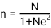
Whereby;
N- Population of the study
n – Sample size of the study
e – Margin of error
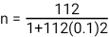
Therefore, the sample size of this study was 105 employees from the Ubungo Municipal Council departments.

3.4 Sampling Technique
A sampling technique is the process of the identifying the entities of the sample that had been selected; therefore. Rationale for choosing it was due to high demand of experts in the field of study. Simple random sampling technique to collect the sample size of 105 respondents from the whole study population.

3.5 Data Collection Methods
Data is a source of information. Data collection refers to gathering of specific information aimed at providing some facts (Kothari, 2004). The researcher used questionnaire in the collection of primary data, whereby questionnaires are the self-administered questions (Gonzalez 2018) that are both structured and semi structured. Formalized questions used in the survey to collect information which is later analyzed to provide necessary results for solving a given research problem (Henninketal, 2020). These would allow respondents to choose from alternatives that were provided by the researcher. On the other hand, the researcher used online sources and journals concerning the issue of employee turnover.

3.6 Primary Data

Primary data is often conducted for specific research when the data are insufficient for the analysis. Primary data are conducted through interviews, participant’s observation, focus group discussion etc. The advantage of primary data is that, its reliability is often generated by a researcher for specific purpose and within a specific context to address a well-defined problem (Kuada, 2008).

Secondary Data
Secondary data is the type that has already been collected and published. It usually consists of articles, books, newspaper, internal and external case, company materials and internet materials (Bryman, 2004). Also, Kuada (2008) argued that, secondary data are those data already available i.e. collected for other purposes but can be used alone or give insight into the markets situation that the analyst is concerned about. They are readily and easily accessible, relatively inexpensive and provide good basis for quick decision on routine problems.
For the purpose of this study, a researcher adopted both primary and secondary data, by reviewing literature on the subject with the view to testing it through questionnaires (i.e. secondary data was gathered through the review of literature and primary data through the application of questionnaire).

3.7 Data Processing, Analysis and Presentation
This was done through inferential statistics because it shows relationship between two variables by using correlation analysis and was a help to summarize data and to show the relationship of the factors behind and the actual impact, which was employee turnover. This was done through Microsoft Excel (Ms Excel). This helped to summarize data into tables and graphs. Data presentation was done through using frequency tables which helped to summarize data into tables using a descriptive statistic such as percentages, and then the researcher was tested the reliability and validity of the data.

CHAPTER FOUR

DATA PRESENTATON AND ANALYSIS

4.1 Introduction
This chapter presented the findings of data, analysis and interpretation. The findings of this research paper were obtained through questionnaire and interview basing on the Factors Leading to Employees Turnover in Public Organizations.

4.2 General Information of Respondents

4.2.1 Age of the respondents

Table 4.1:Age of the respondents
 |  | Frequency | Percent | Valid Percent | Cumulative Percent
Valid | 18 - 35 | 32 | 30 | 30 | 30
 | 35 – 50 | 34 | 33 | 33 | 63
 | Above 50 | 39 | 37 | 37 | 100.0
 | Total | 105 | 100.0 | 100.0

Source: Research data (2022)
Age of the respondents is very important in the process of data analysis, as the age of respondents reflects their opinions, views and concerns, the respondents of the study questionnaire filled their age groups, and the results were presented on table 4.1 above, whereby age group 18 -35 had 32 respondents (30%), 35 -50 had 34 respondents (33%) and age group of respondents aged above 50 years had 39 respondents (37%).
Therefore, the age group above 50 years had a highest frequency rate of 37%, this shows that majority of the employees at Ubungo municipal offices, are matured, experienced and competent staff towards their activities, in all departments of the district, thus providing reliable data findings in this study.

4.2.2 Gender of the respondents

Table 4.2: Gender of the respondents
 |  | Frequency | Percent | Valid Percent | Cumulative Percent
Valid | Male | 71 | 68 | 68 | 68
 | Female | 34 | 32 | 32 | 100.0
 | Total | 105 | 100.0 | 100.0
Source: Research data (2022)

Findings shows that 71 respondents (68%) were male and female were 34 (32%), this shows that majority of the employees of Ubungo municipal offices are male; this signifies the presence of gender imbalance in the organization.

4.2.3 Working experience

Table 4.3: Respondents’ working experience
 |  | Frequency | Percent | Valid Percent | Cumulative Percent
Valid | «1 yr | 8 | 7.6 | 7.6 | 7.6
 | 1 – 5 yrs | 39 | 37 | 37 | 44.6
 | 5 – 10 yrs | 41 | 39 | 39 | 83.6
 | 10+ yrs | 17 | 16.4 | 16.4 | 100.0
 | Total | 105 | 100.0 | 100.0

Source: Research data (2022)
Demographic information that was collected by the researcher is the working experience of the respondents, as it is also important towards their level of knowledge on the subject matter, whereby staff with many years of working experience tends to be more competent and knowledgeable comparing to the staff with less working experience.
Data shows that 8 respondents (7.6%) had a working experience of below 1 year of working, 39 respondents (37%) had a working experience of between 1 to 5 years of working, 41 respondents (39%) had a working experience of between 5 to 10 years of working and 17 respondents (16.4%) had a working experience of 10 years and above.
This shows that majority of the officers at Ubungo municipal are well experienced in their jobs, as the working experience with the highest response was 5 to 10 years of working by 41 respondents.

4.3 Presentations of Findings analysis & Discussion
After the identification of demographic features of the respondents the researcher collected data to answer the research questions in accordance to the specific objectives of this study, which were;
    - To find out the main causes of employee’s turnover at Ubungo Municipal Council
    - To establish the main forms of employee turnover at Ubungo Municipal Council
    - To determine the strategies which can be adopted to retain employees at Ubungo Municipal Council

4.3.1 Main causes of employee’s turnover at Ubungo Municipal Council.
The first research objective for this study was to identify the main causes of employees’ turnover at Ubungo Municipal Council. Questionnaires were distributed and the following data were collected and presented.

Figure 4.1: Causes of employee turnover
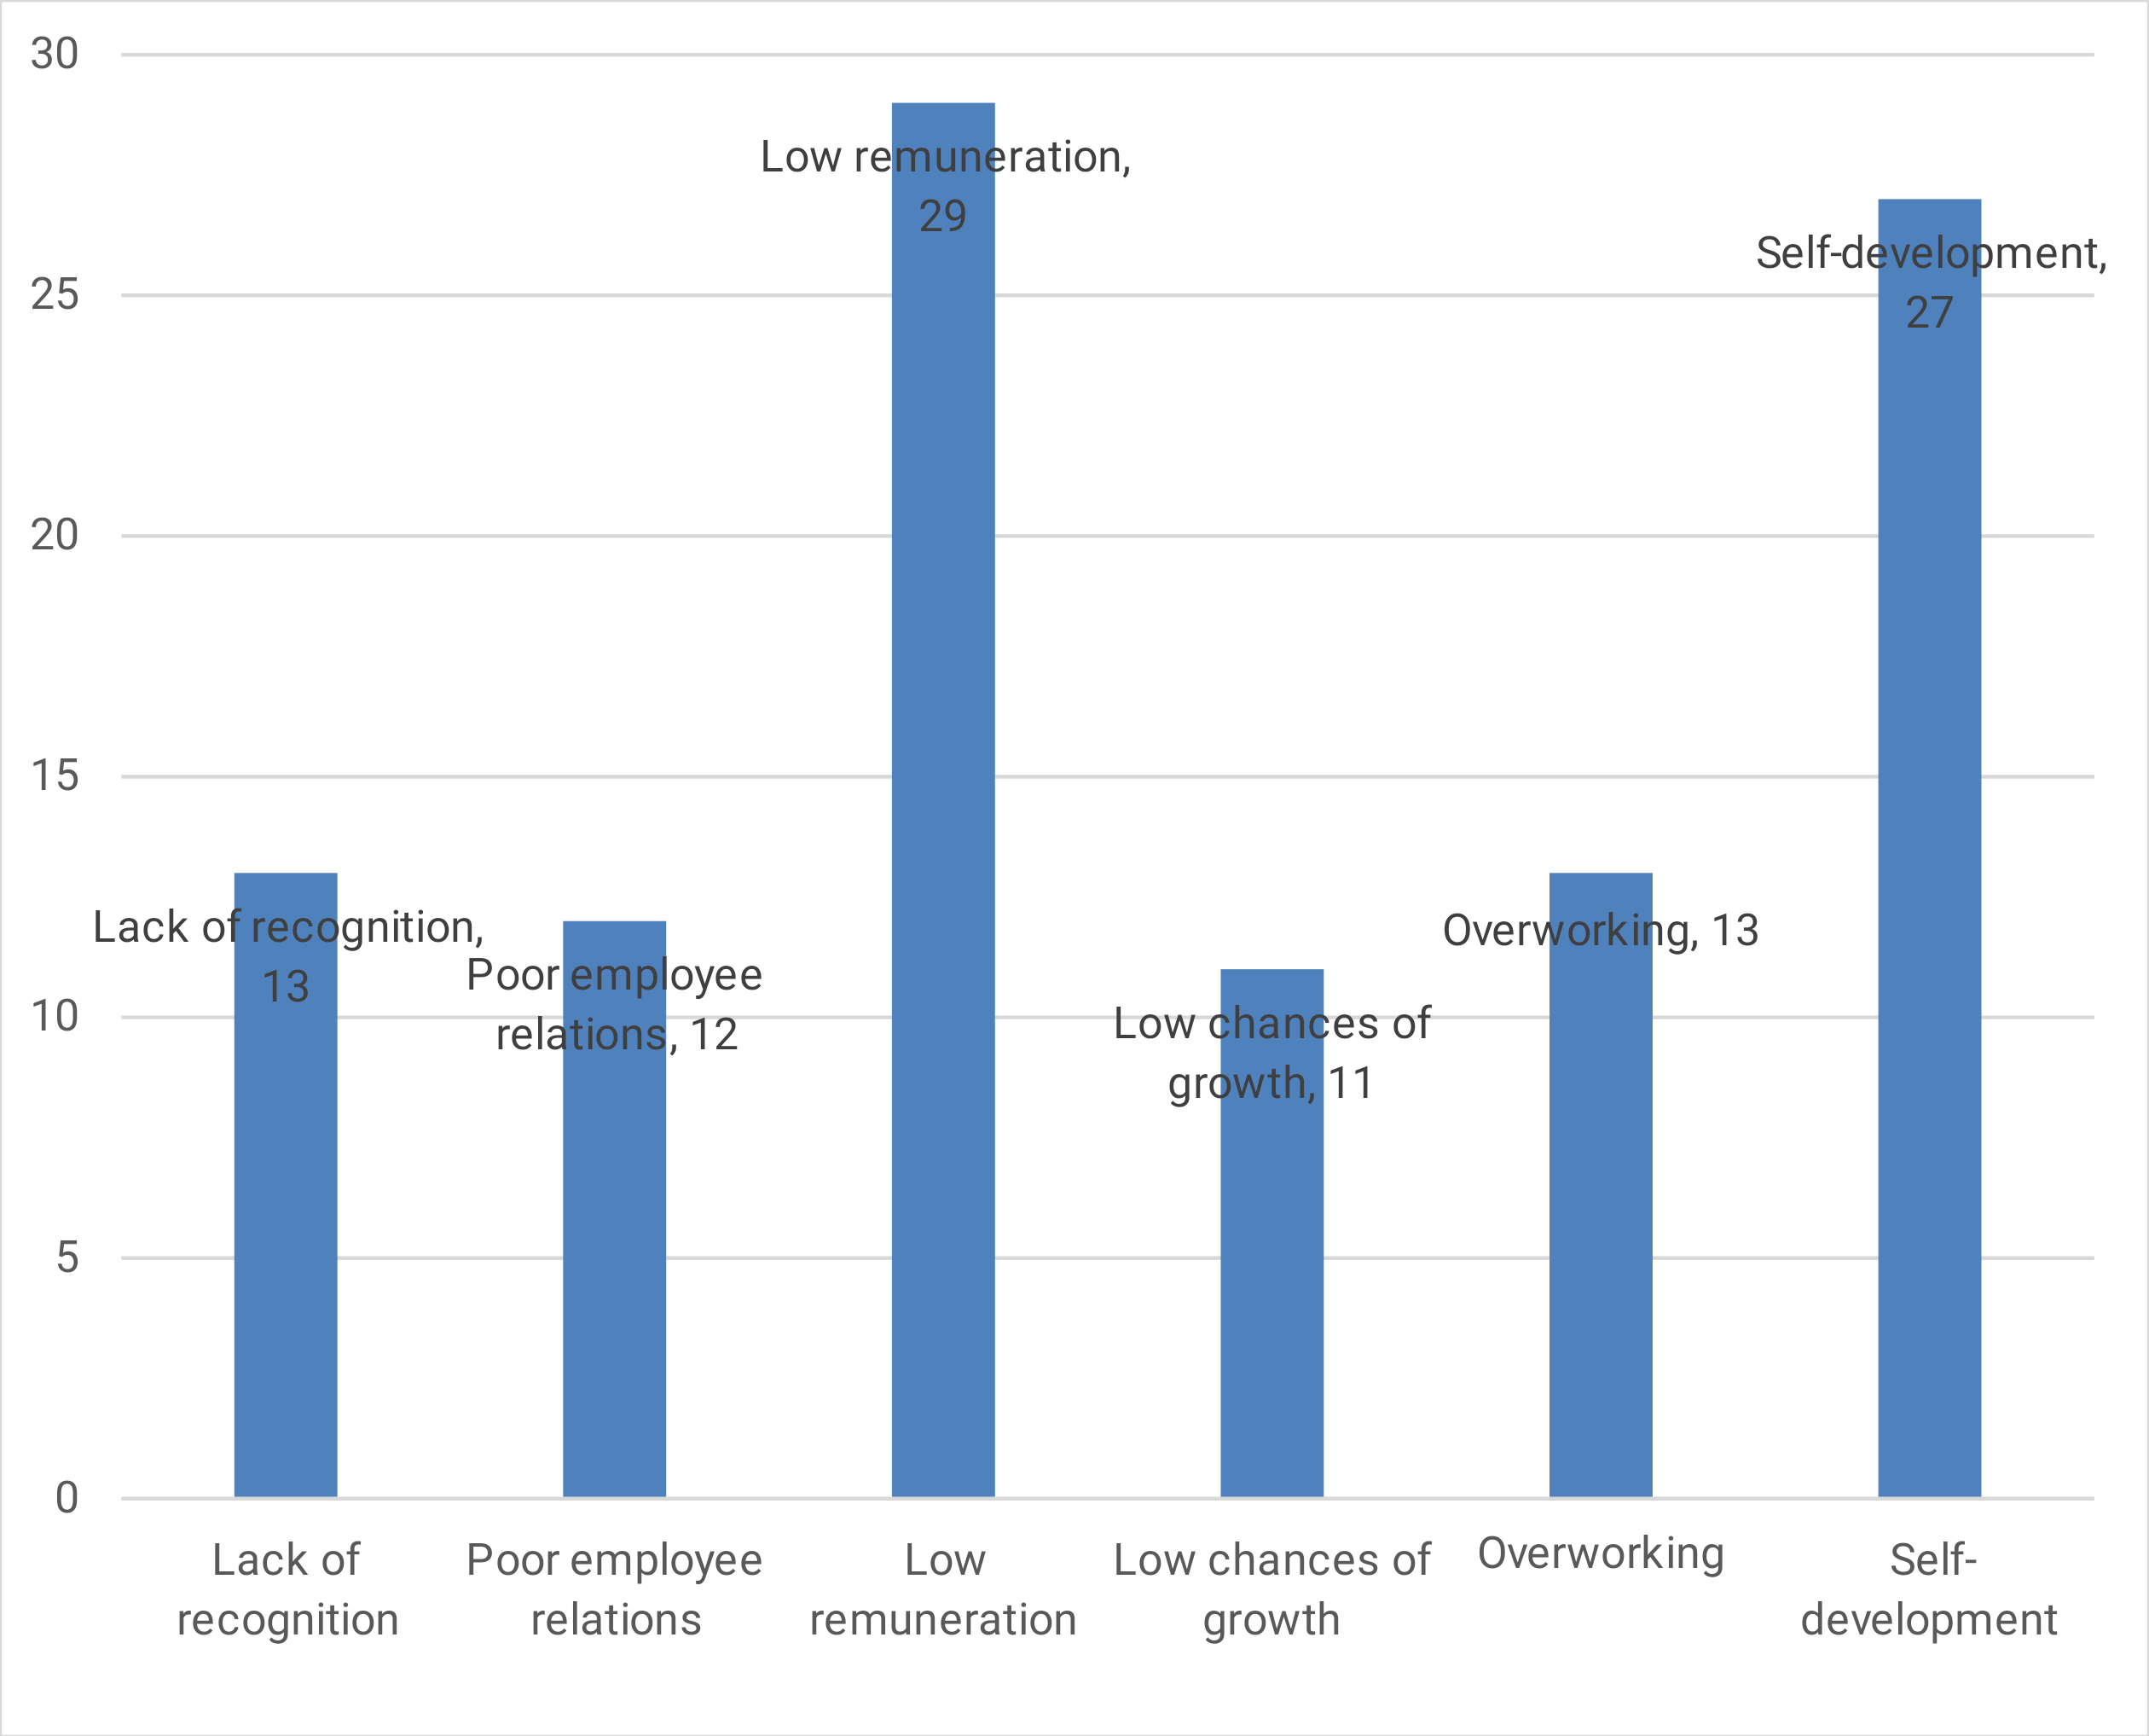
Source: Research data (2022)
The respondents responded towards different causes of employee turnover at Ubungo Municipal Council, whereby the identified causes can be identified as internal causes and the external causes, example of internal causes are such as lack of recognition, poor employee relation and overworking while the external causes identified includes self-development and low remuneration in comparison with the friends working from another organizations.

The findings shows that the leading cause of employee turnover at Ubungo municipal council is the issue of low remuneration as it had the highest frequency of 29 responses (29%).

Other causes leading to employee turnover that were responded by the respondents includes lack of recognition responded by 13 respondents (12%), poor employee relations within the organization responded by 12 respondents (11%), low chances of growth responded by by 11 respondents (10%), overworking responded by 13 respondents(12%) and the issue of self development which was responded by 27 respondents (26%), as the leading external factor as it is not an organizational concern.

4.3.2 Main forms of employee turnover at Ubungo Municipal Council
Figure 4.2: Forms of Employee turnover
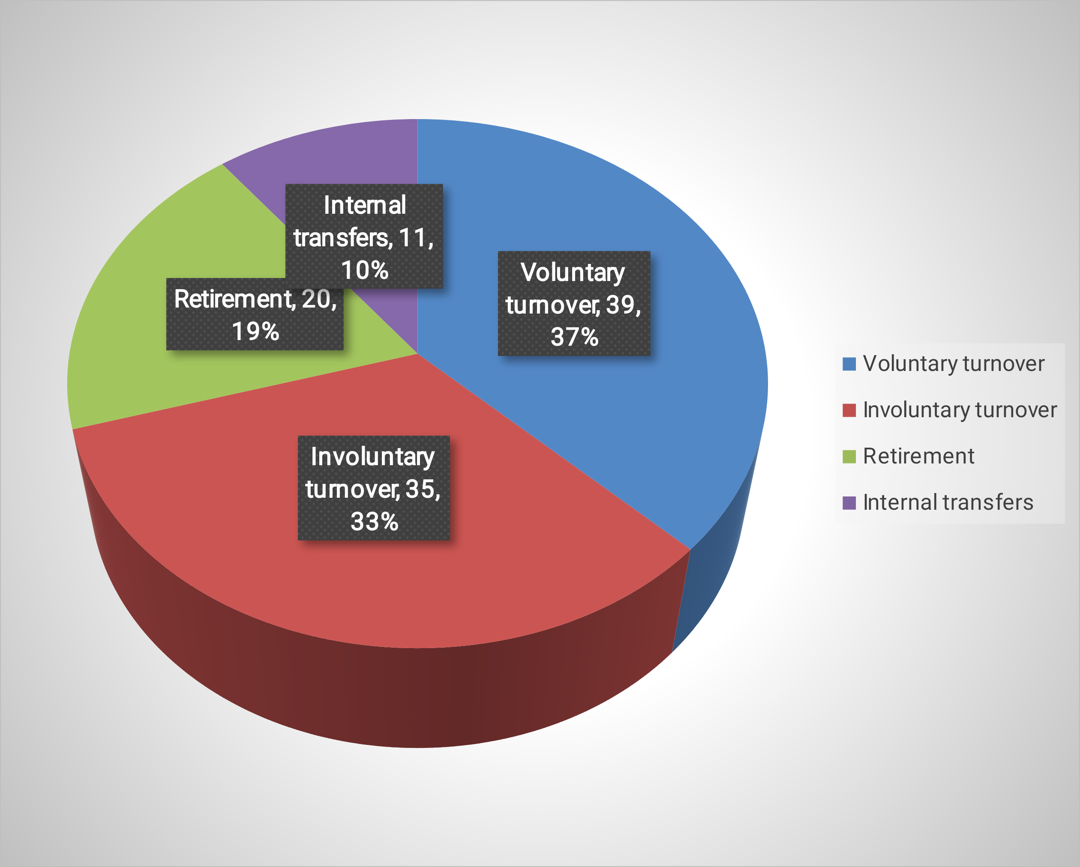
Source: Research data (2022)

The second of this study based on the identification of the min forms of employee turnover at the Ubungo municipal council, and the main four forms of employee turnover that were identified are; voluntary turnover, involuntary turnover, internal transfers and retirement.

Whereby, the voluntary turnover had the highest response rate, as it was responded by 39 respondents (37%) of the sample size included in this study, followed with the involuntary turnover which was responded by 35 respondents (33%) of the study sample, this implies that majority of the employees at Ubungo municipal council are neither retiring, dying ir being transfer, but the majority are leaving their jobs due to the various reasons which might be of the organization management or self reasons, of which most of the times are the self-development matters.

Other forms of employee turnover identified at Ubungo municipal council are retirement and internal transfers responded by 20(19%) and 11 respondents(11%) respectively.

4.3.3 Strategies which can be adopted to retain employees at Ubungo Municipal Council

Figure 4.3: Employee retention strategies
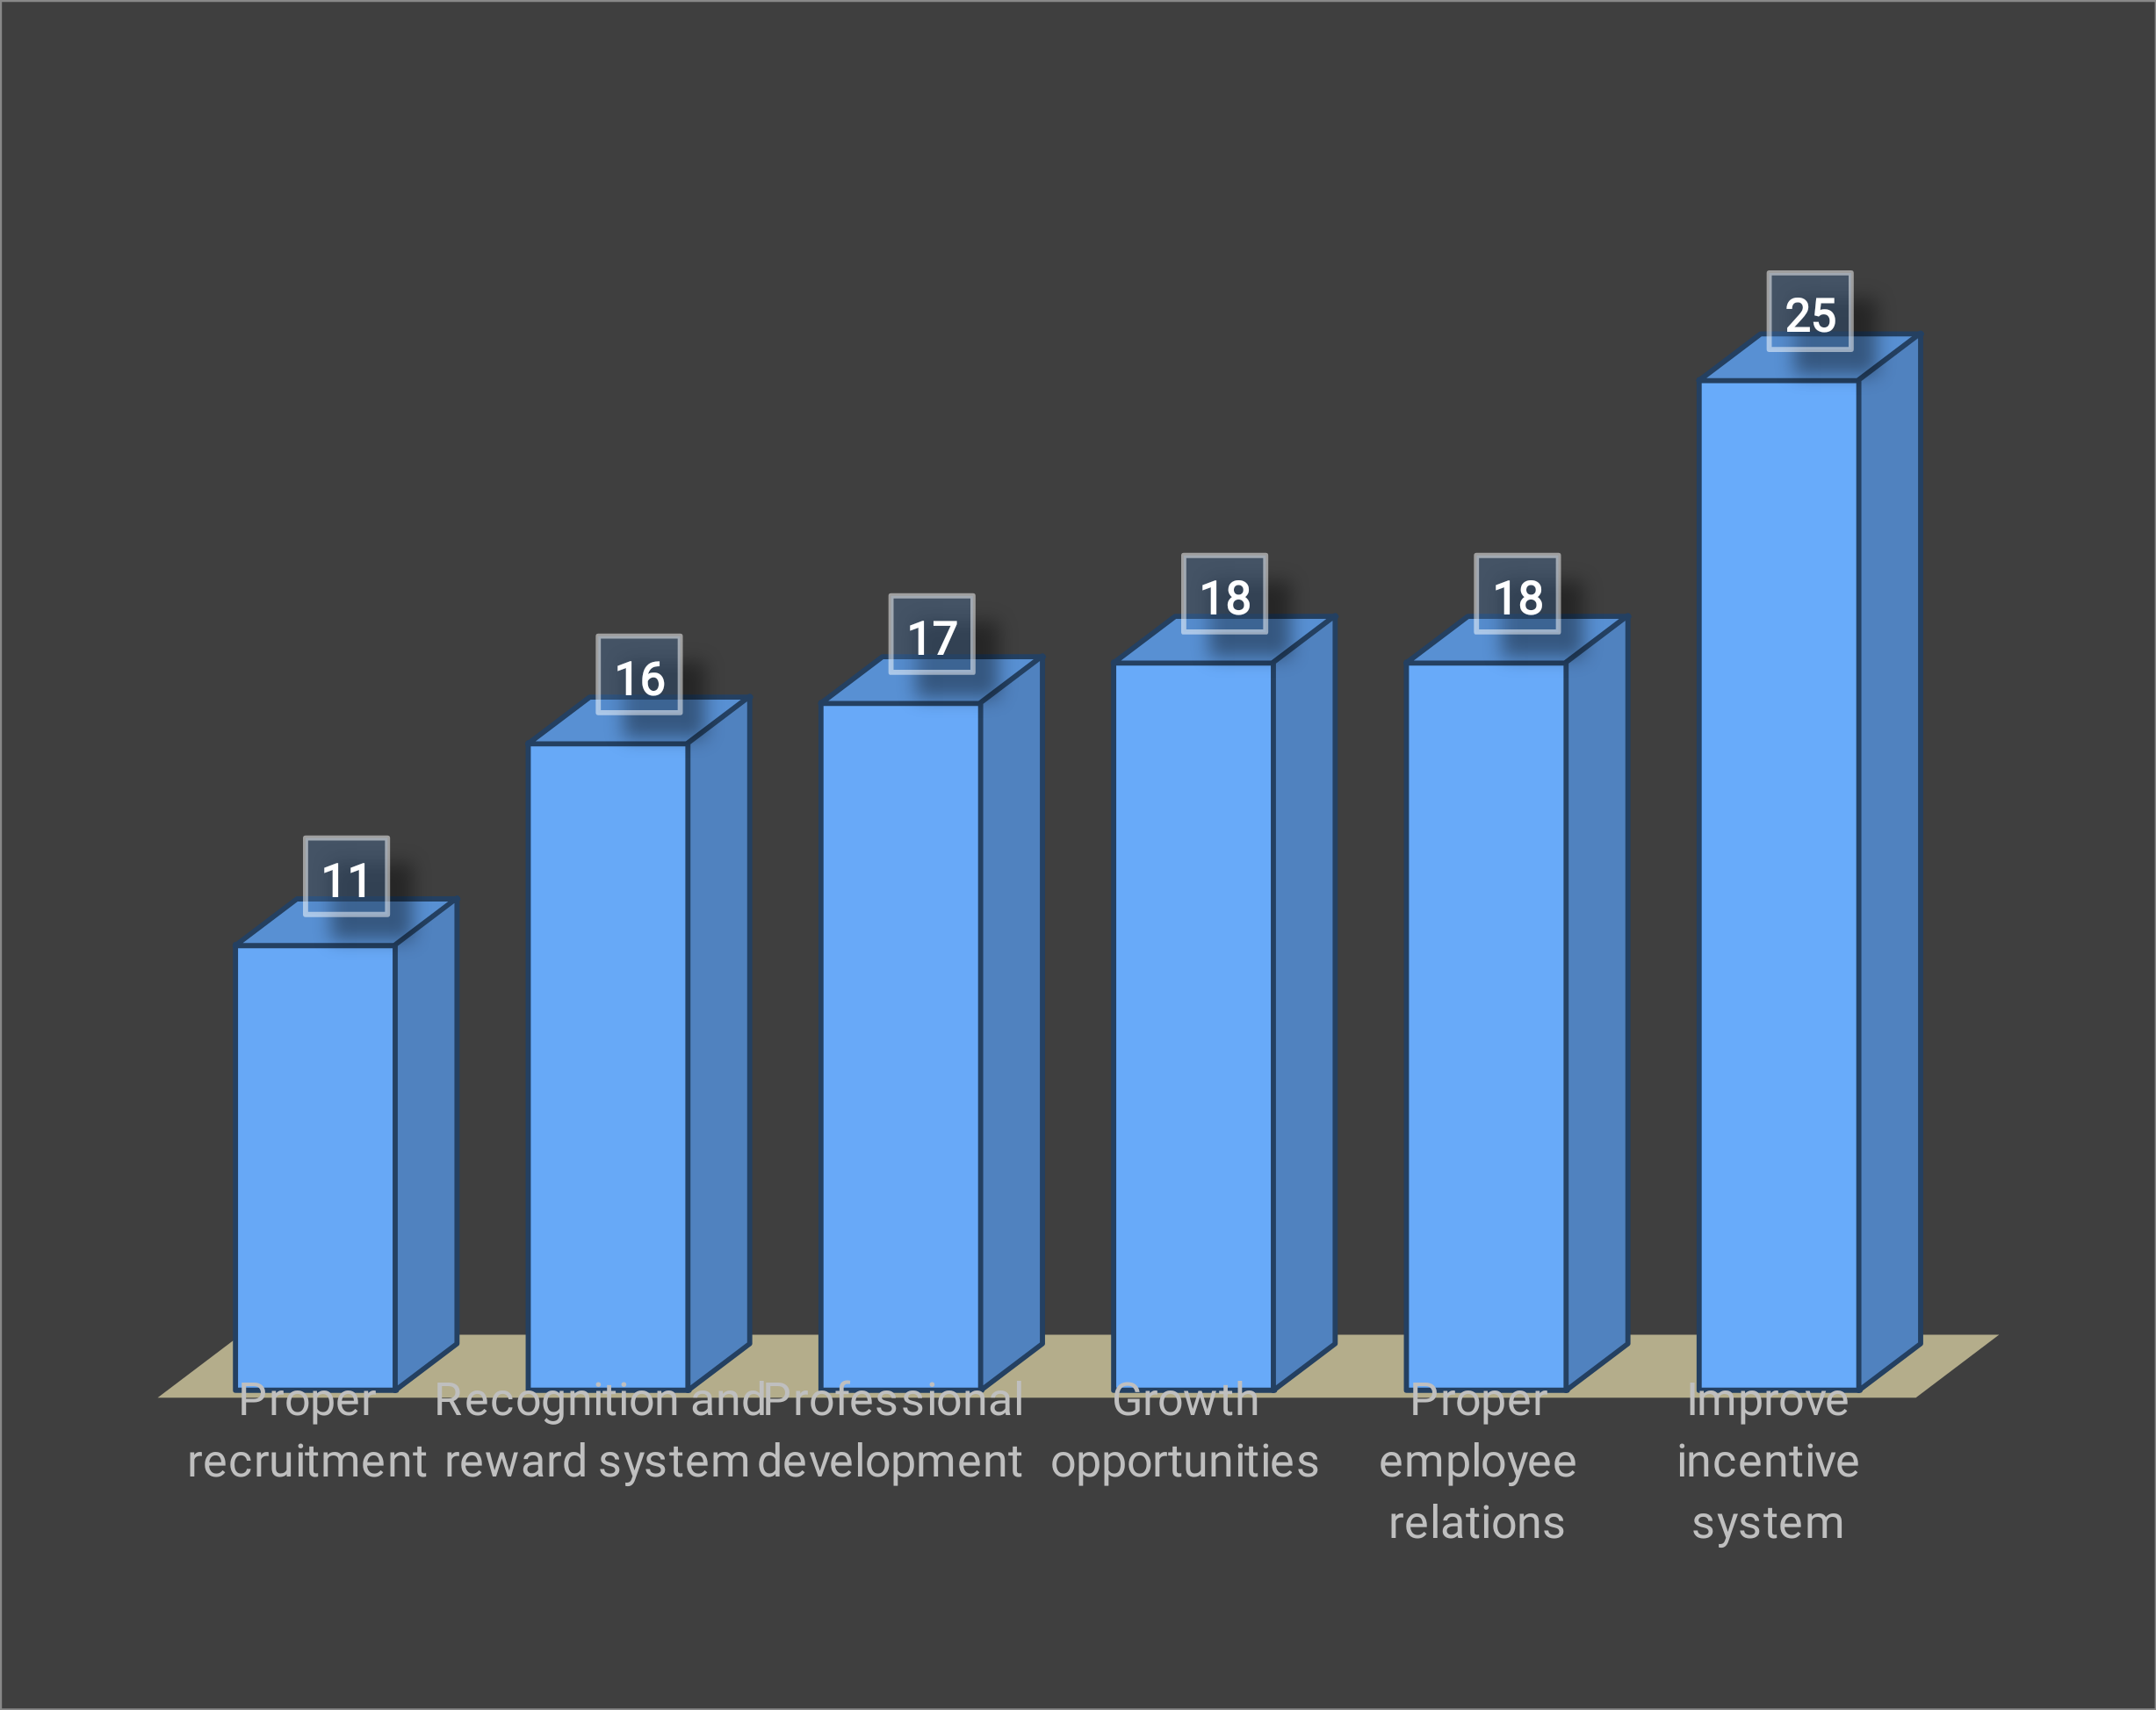
Source: Research data (2022)
The last specific objective of this study focused on the solution part towards the problem of employee turnover in the organization, whereby the researcher intended to identify the strategies which can be adopted to retain employees at Ubungo municipal council.

The findings have revealed that there are many strategies that help to overcome this challenge, 11 respondents (10%) responded on proper recruitment as a way to deal with high turnover rate in the organization, which means selecting employees with a need to work, dedicated and qualified towards the job specifications, 16 respondents (15%) responded on the establishment of the recognition and rewards system, 17 respondents(16%) responded on professional development, 18 respondents(17%) responded on creation of growth opportunities to the employees as a way to overcome the issue of employee turnover, other 18 respondents(17%) responded on proper employee relations by the management and subordinates and 25 respondents(24%) responded on improving the incentive system by the organization.

CHAPTER FIVE

SUMMARY, CONCLUSION AND RECOMMENDATIONS

5.1 Chapter overview
This Chapter commences with a summary of the study explaining important elements including the purpose of the study, specific objectives, research methodology used and major findings or results. It presents implication of the major findings of the study. This chapter also concludes the research by providing the conclusion and recommendations as presented below regarding to the findings presented on chapter four above.

5.2 General Summary
The purpose of the study was to determine the factor that are associating employee’s turnover in Public Organization. One hundred and five (105) respondents who work at Ubungo Municipal Council were engaged in the study, all respondents participated. These workers were in the form of information and technology and others such as the Finance officer, Accountant, Human Resource personnel. This study used quantitative approach. This study adopted case study design to determine factors which may associate employee’s turnover at Organization. Questionnaires were used as the survey instrument. Stratified random sampling technique was used to select respondents from the entire population. A sample size of 105 was drawn from the study population 112. The data were collected by using structured questionnaires. Descriptive statistics and were used to analyze data collected from the respondents and excel Microsoft application were used to process data.

5.3 Summary of findings
On the basis of the findings from this study as presented, analyzed and interpreted in chapter four, basing on the main objective of this study which was An Assesment to determine the factors leading to Employees Turnover in Public Organizations, A case of Ubungo MMunicipa Council. The study has revealed that employee turnover is a long term problem in the public organizations influenced by a number of factors as discussed above.
On the issue of recognition in the workplace, the researcher revealed that 75% strongly agreed that senior staffs enjoy more recognition than junior staffs, 60% strongly agreed recognition is well structured within the Ubungo Municipal Council, however, it is most accorded to Senior staff members,80% of the respondents strongly agreed that the opinions of employees are undervalued. Also, the findings revealed that about 45% of respondents had the opinion that additional qualifications of employees are not recognized all these factors revealed has led to the great turnover impact in Ubungo municipal Council industry. There is little evidence of a person’s sex being linked to turnover. Griffeth et al’s (2020) examined various personal characteristics that may be linked to turnover and concluded that there were no differences between the quit rates of men and women. They also cited evidence that gender moderates the age-turnover relationship (i.e; women are more likely to remain in their job the older they get, than do men).
On the issue of promotion opportunities, the findings revealed that 80% of respondents agreed that qualifications are considered for promotion,70% said work experience and performance are the main criteria considered during promotions 80% of respondent strongly agreed that performance is considered for promotion only 4% of the respondent strongly disagreed that gender is considered during promotion 24%strongly agreed ,and 45% agreed that gender is considered during promotion , the research findings revealed that respondents disagreed that gender equality is considered during promotions, and that is why there are very few females in management positions of Ubungo municipal Council, this justify that employees who are promoted are less likely to have the intention to leave the their current job than who are not promoted, promotion is among the tool that can be used by employer to retain the employee if done properly and reduce the rate of staff turnover in Ubungo municipal Council.
These findings are congruent with the findings of a study conducted by Kilborn (2020) who reported that individuals who are promoted are 58% less likely to have the intention to leave their current employer compared to employees who are not 58 promoted. This suggests that promotion is among the tools that can be used by employers to retain employees and reduce the rate of staff turnover.
From the study, the researcher found out that the intention to quit among employees diminishes with advancement of age. Also, the intention to quit increases as the level of education of employees increases and decreases as level of work experience increases. This is because as employees become more experienced and move up the corporate ladder from, they become well paid and jobs and less likely to leave. The researcher revealed that the employee turnover rate at the Ubungo municipal council from the year 2007 to the year 2012 has stood at approximately 12%. This means in any given year, out of 100 employees of the Ubungo mmunicipa council, 12 leave for various reasons.

5.4 Recommendations

5.4.1 Recommendations to organization
- Employee selection should rechecked, the management of Ubungo municipal Council should look again at the selection process. Initial screening and interviewing can help avoid future turnover as well as prevent employees from leaving.

- Job description should be revised, job description should include; job function, duties, responsibilities and qualifications. This will help to informs applicants of details of job parameters. Thus, the employees would know what to expect from the job and what the company expects from them. In addition, the application process should give the employer other insights into the candidate. The interview is the most important part of the hiring process. In a limited period of time, the interviewer must determine accurately if the applicant has the skills required and a good attitude.

- Emphasis on retention scheme. Ubungo municipal Council should put more emphasis on employee retention as a corporate goal. More attention and effort by the management should be allocated to increase employee retention.

- Introduction of career development. Ubungo municipal council should introduce career development programs. Training helps to improve job skills, knowledge and understanding and improves attitudes and employee behavior, and thus reduces of employee turnover.

- Recognition of Personal occasions. Ubungo municipals council should recognize personal occasions such as birthdays, employment anniversaries, and wedding anniversaries and other special accomplishments and occasions such as family days and get-together parties. These little things do not require much effort and can bring significant impact of employee’s retention.

- Management of employee turnover. The management of Ubungo municipal council must learn how to deal with employee turnover and the effects it has on their Ubungo municipal council and should be better prepared to take the proper actions after a turnover event occurs. All efforts should be focused on maintaining employee job satisfaction and managing controllable causes of turnover.

- Increment of salary and other benefit. Ubungo municipal council should increase the amount of salary paid to employees and offer attractive benefits such as leave, loans, medical care and performance bonuses. These will go a long way to reduce employee turnover and its impact on the performance of the Ubungo district municipal.

- Improvement of working conditions. Ubungo municipal council should improve work conditions by making sure that employees have all the necessary tools they need to perform their duties effectively without stress or too much work.

5.4.2 Recommendations for further researches
As indicated in earlier chapters, many studies have been conducted turnover and retention. This study was specifically intended to assess the causes of labor turnover in organization; however, it is suggested that other studies to be conducted in the following area, impact of labor turnover into performance in organizations.

REFERENCES
Al Mamun, C. A and Hasan, N. (2017). Factors affecting employee turnover and sound retention strategies in business organization: A conceptual review. Dhaka.University of Information Technology and Sciences.
Armstrong, M. (2006).A Hand Book of Human Resource Management, Tenth Edition. London. Kogan Page
Armstrong, M. (2003). A Hand Book of Human Resource Management, sixthEdition. London. Kogan Page
Brookes M, Brewster C and Wood G (2005) Social relations, firms and societies: A study in institutional embeddedness. International Sociology 20(4): 403–426.Companies.
Chuwa A. (2013) Employment and earnings survey 2012: Analytical report. The National Bureau of Statistics.
Croucher, R., Brewster, C and Brookes, N. (2012).Employee turnover, HRM and institutional contexts. Sweden. SAGE Publication.
Gonzalez-Franco, M., & Peck, T. C. (2018). Avatar embodiment. towards a standardized questionnaire. Frontiers in Robotics and AI, 5, 74.
Grobler, P.A. et al (2006). Human resource management in South Africa. London: Thompson.
Hyemann, M. (2010).The Impact of Demographics on Voluntary Labour Turnover in South Africa. Pretoria. University of Pretoria.
Ingram, D. (2018). Relationship between Work Environment and Job Satisfaction in an Organization for Employee Turnover.Chron Publication.
Jagun, V. (2015).An Investigation into the High Turnover of Employees in the Irish Hospitality Sector: Identifying What Methods of Retention Should be Adopted. Ireland. National College of Ireland.
Jarman, G. (2017). Future of the Global Workplace: Coping with High Turnover. St James Avenue, Boston. The Radius Blog.
Joan E. P. (2004). A hand book of Human Resources Management for Public and non – profit organizations. Jossey-Bass Wiley Imprint.
Kazi G.F. & Zedah Z.F (2011). The contribution of individual variables: job satisfaction and job turnover. Interdisciplinary journal of contemporary research in business, VOL 33(5), 984 – 99.
Kothari, C. R. (2004). Research Methodology: Methods and Techniques (Second Edition). New Delhi, India. New Age Publishers.
Kweka, A. N. and Sedoyeka, E (2014).Labour Turnover in Tanzania: Telecom vs Ubungo district municipaling sectors. International Journal of Computing and ICT Research, Vol. 8, Iss 2. Pp. 65-82. Tanzania. Institute of Finance Management.

APPENDICES

Appendix One: Questionnaires to Employees
My name is Rosalia Nziku, a student of the Institute of Social Work (ISW), pursuing Bachelor’s degree in Labour Relations and Public Management (BLRPM). I am conducting a research study to determine ‘the factors leading to Employees Turnover in Public Organizations, A case of Ubungo Municipal Council’.I kindly request you to participate in this study by answering the questions below which will be used for academic purpose only and your identity will remain anonymous.
In each section, tick the box or fill in your response in the space provided as appropriate.

Section A: Demographic Information
- How old are you?
- 18-35 [ ]
- 35 - 50 [ ]
- Above 50 [ ]
- What is your gender?
- Male [ ]
- Female [ ]
- How long have you been working at Ubungo municipal council?
- Below 1 year [ ]
- 1 to 5 years [ ]
- 5 to 10 years [ ]
- Above 10 years [ ]

Section B: Study Questions
Please tick against the most appropriate answer
Strongly agree – 1, Agree – 2, Neutral -3 . Disagree -4, Strongly disagree – 5
PART I: Main causes of employee’s turnover at Ubungo Municipal Council

Please tick to the cause of employee turnover that you know |  | 1 | 2 | 3 | 4 | 5
1 | Lack of recognition
2 | Poor employee relations
3 | Low remuneration package
3 | Low chances of growth
4 | Overworking
5 | Self-development
5 | Please mention any other causes of employee turnover at Ubungo municipal council  - ..............................................................................................................  - .............................................................................................................  - ..............................................................................................................

PART II: Main forms of employee turnover at Ubungo Municipal Council
Please tick to the form of employee turnover that has been taking place at Ubungo district municipal |  | 1 | 2 | 3 | 4 | 5
1 | Voluntary turnover
2 | Involuntary turnover
3 | Internal transfer
4 | Retirement

PART III: Strategies which can be adopted to retain employees at Ubungo Municipal Council
Please tick against the strategy that can be sued to retain employees |  | 1 | 2 | 3 | 4 | 5
1 | Proper recruitment
2 | Recognition and rewards system
3 | Professional development
4 | Growth opportunities
5 | Proper employee relations
6 | Improving the incntive and reward system
7 | Please mention any other strategy which can be adopted to retain employees that you know:  - ..............................................................................................................  - .............................................................................................................  - .............................................................................................................

‘Thank you for your time’

